INSTRUCTIONS TO THE NEW COUPLE VISITING JAYA SUPER-SPECIALTY FERTILITY CENTRE

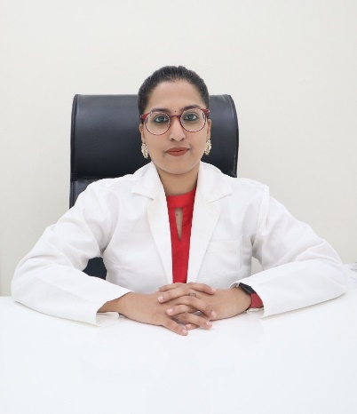 | BOOK PRIOR APPOINTMENT  - We will be able to serve you better  - Less/No waiting period  - Save time/Quicker consultation  - Avoids non-productive visits  - Saves your money  - Reduces mistakes  - Better planning  - Convenient  - Allows at home video consultations when needed/possible to reduce your visits to the center
CONTACT (IN CASE OF AN EMERGENCY)  +917093075968 (Doctor’s personal number)  (WhatsApp available)  e-mail: rajyalakshmipriyanka@gmail.com (Personal email) | FOR DIRECT APPOINTMENTS  Contact: 6302410848  Google location/page:  Consultation timings:  Monday to Saturday: 11:00 AM – 8:00 PM  Sunday: 10:00 AM to 1:00PM

SEPARATE MALE AND FEMALE REPORTS/DOCUMENTS
MALE DOCUMENTS
FEMALE DOCUMENTS

- Fill the treatment summary form including
  - Start of treatment – Month/Year/Place
  - Month to Month Treatment update
- In case of online/video consultation
  - All the reports and treatment summaries should be scanned and arranged date-wise and shared on the call
  - Treatment summary form shared to you should be filled in and shared by scanning or direct filling on system

- Arrange all documents date-wise
- Documents include previous treatment summary, blood tests, semen analysis, genetic tests
- Arrange all documents date-wise
- Documents include previous treatment summary, blood tests, tubal testing, genetic tests

